**Assignment 19.3:**

Create a dataframe with 1 to 100 and save as parquet file:

**Load the number into variable**

**Creating RDD using the variable**

**Creating dataframe using RDD**

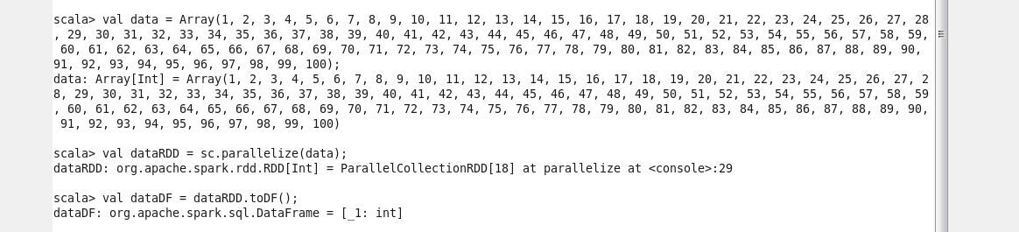

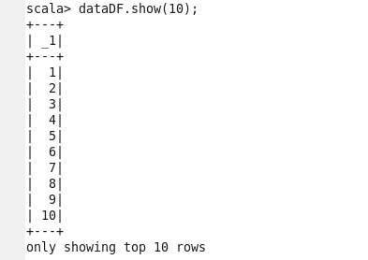

**Store dataframe as parquet file:**

